Local Deployment Setup

# Application and Tools to install

* ASP.NET Core 6.0 Runtime (v6.0.6) - Windows Hosting Bundle Installer ([Link](https://dotnet.microsoft.com/en-us/download/dotnet/thank-you/runtime-aspnetcore-6.0.6-windows-hosting-bundle-installer))
* IIS Setup
* Visual Studio 2022 and MySQL (please refer to Development Environment Setup guide)

# Installation/Setup

## ASP.NET Core 6.0 Runtime (v6.0.6) - Windows Hosting Bundle Installer

1. Download the installer from this [link](https://dotnet.microsoft.com/en-us/download/dotnet/thank-you/runtime-aspnetcore-6.0.13-windows-hosting-bundle-installer) and click the Direct Link.
2. Open the installer once downloaded.
3. Check the ‘I agree to the license terms and conditions’ and click Install. 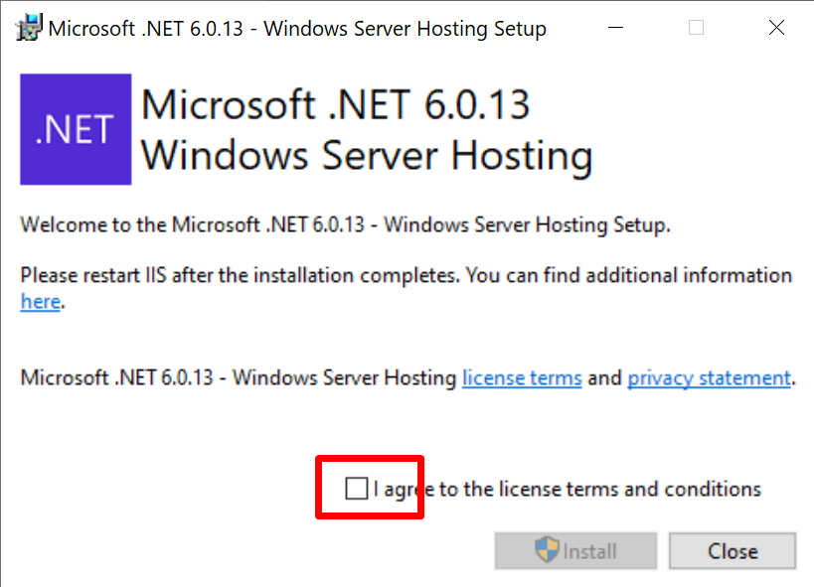
4. Click Close button once installation is done.

## Local IIS Setup

1. Check your all IIS Services are running on your system properly or not. If not then open the control panel and go to the program and features and click on Turn Windows Feature on or off. 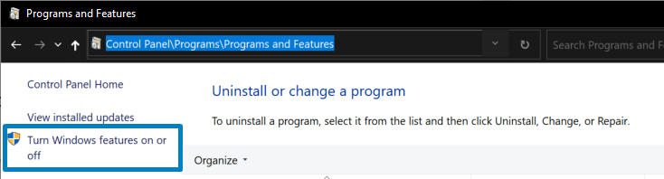
2. Apply the changes shown in the image and click OK to apply the changes and restart your computer.

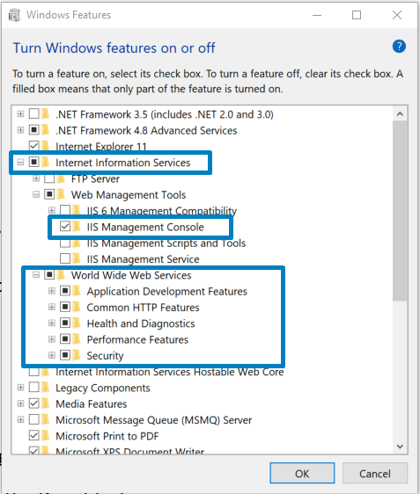

1. After restarting your computer will see IIS Manager in the search box and open it.

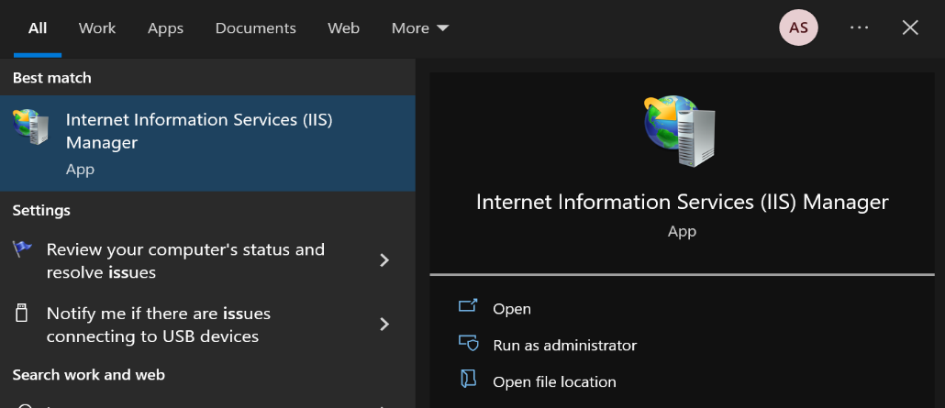

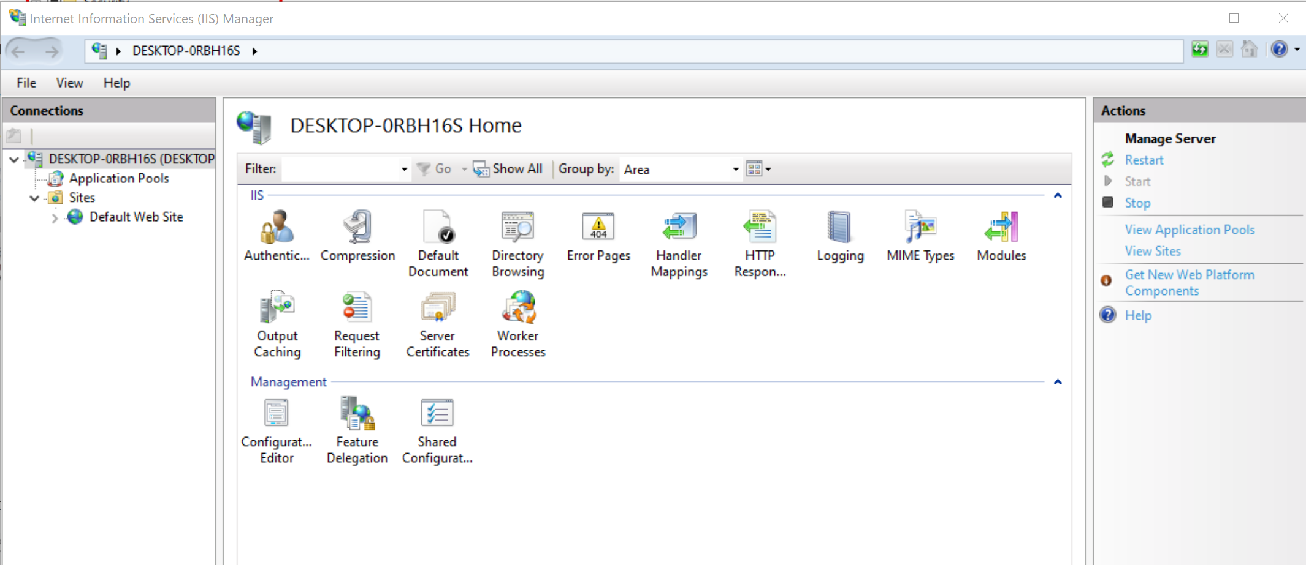

Now, check your running IIS using localhost in the browser

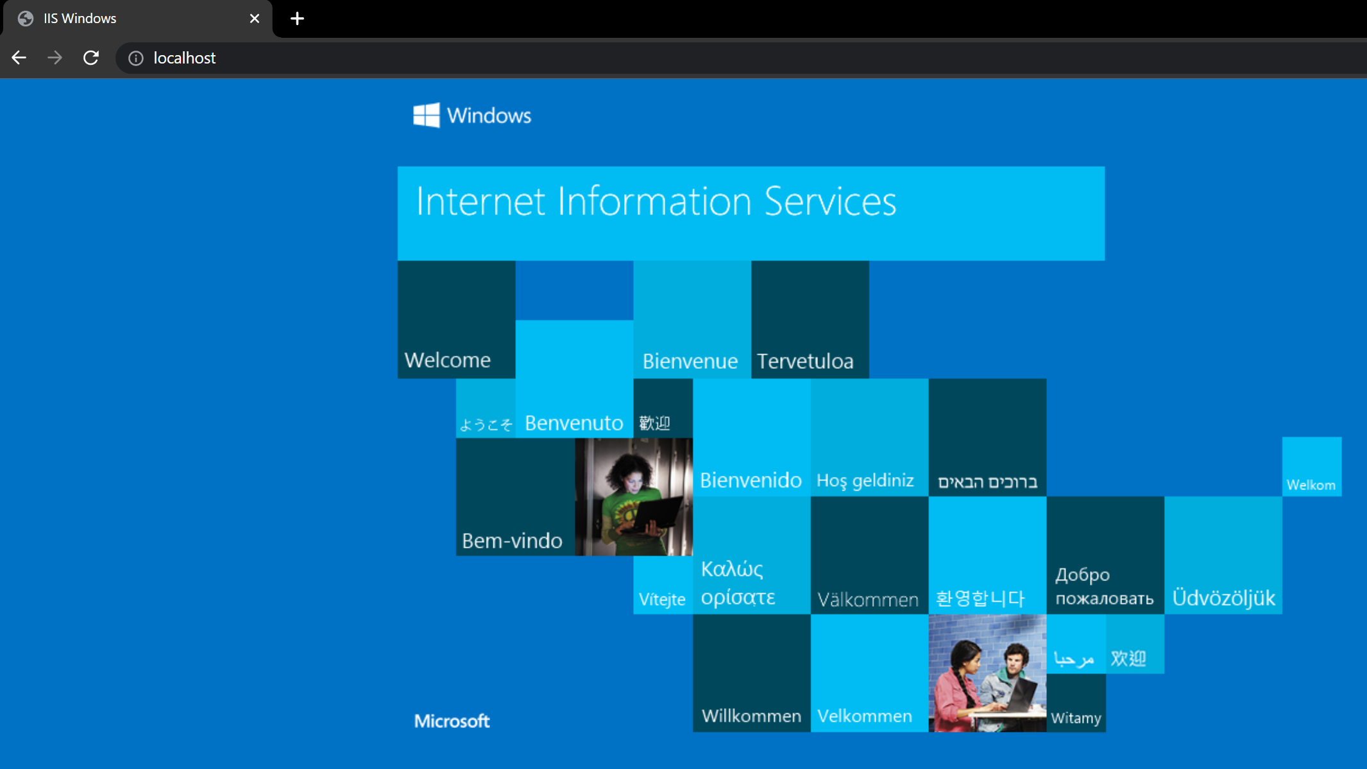

## Publishing BBIS

1. Open the BBIS solution in VS and right click the BBIS.Api and select the Public menu option. 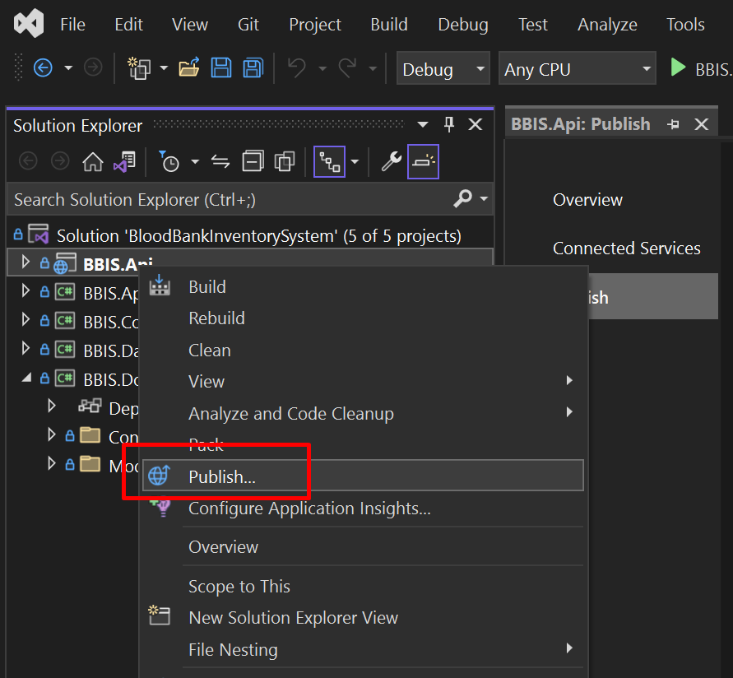
2. On the Publish tab, if you don’t have existing publish config select the + New button to create a publish configuration. 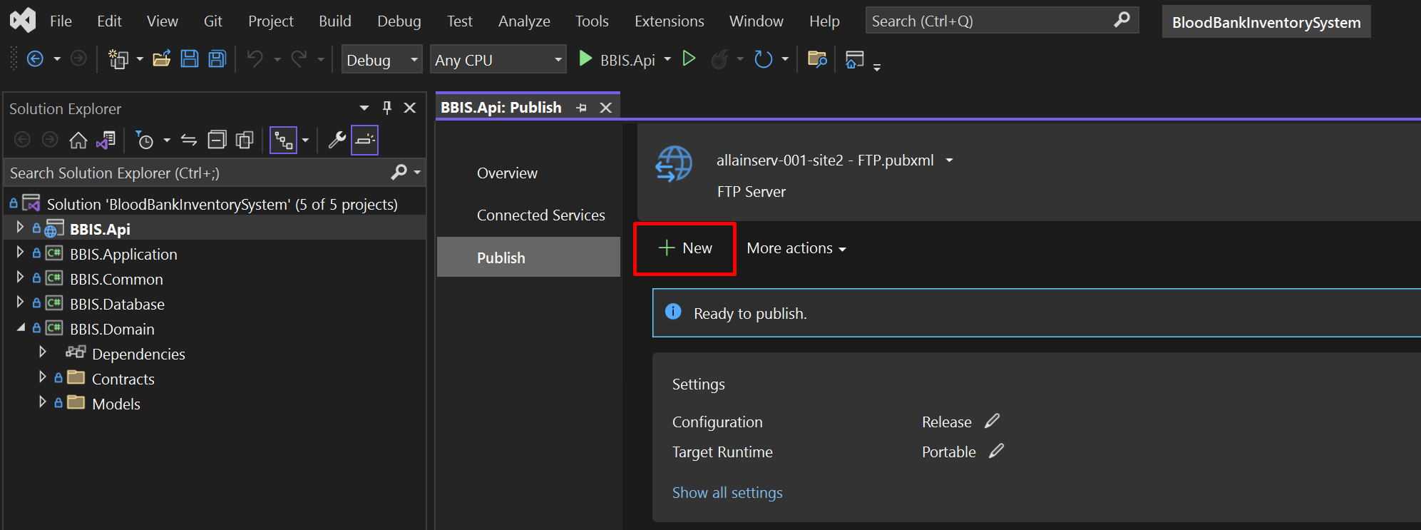
3. 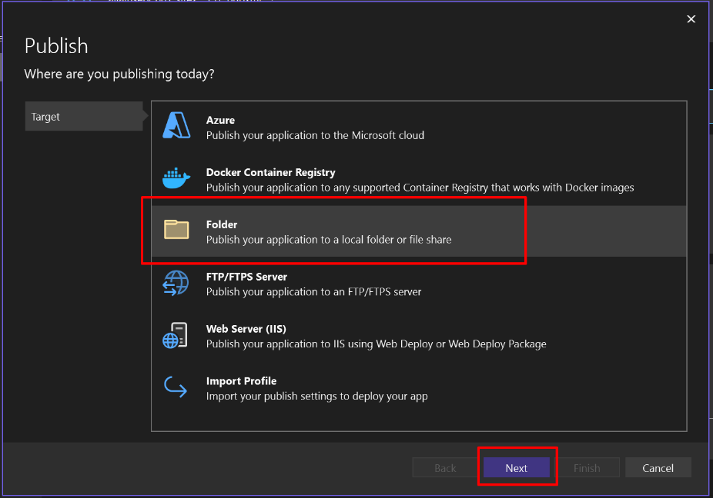Select Folder and Click next
4. 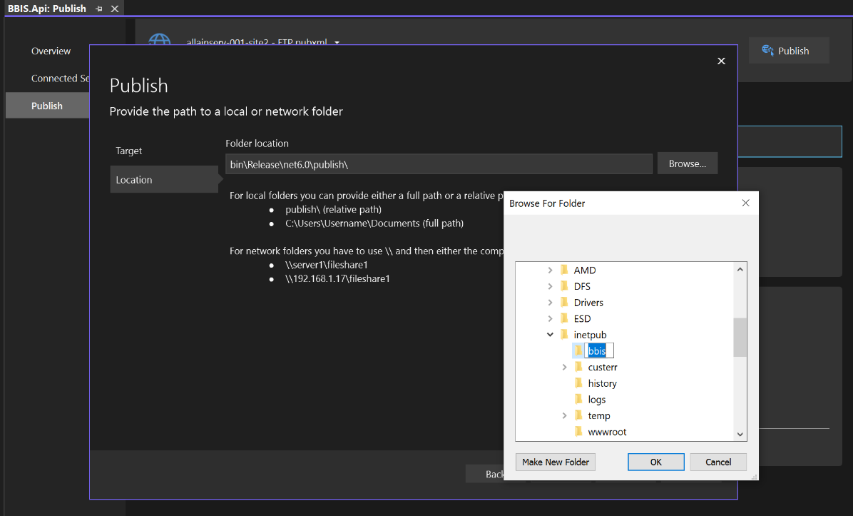Select the location or folder to which the published files will be hosted from. Click Browse… button then create a folder to your preffered location and click OK then click Finish.
5. Go back to publish tab, click the Show all settings and Publish dialog will appear and follow the configuration highlighted in the image. 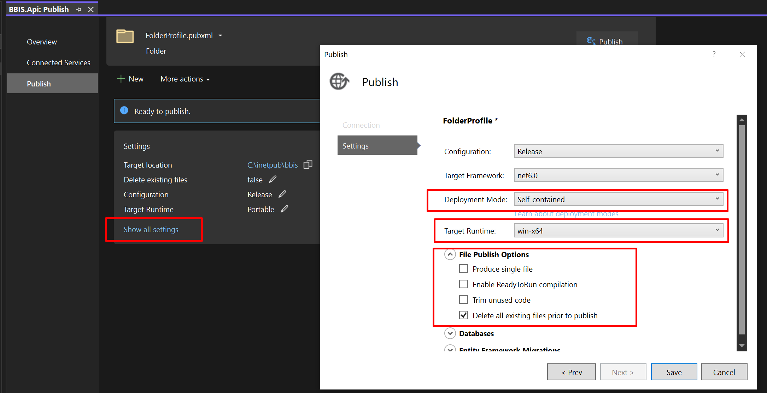

Make sure to set the correct database connection string.

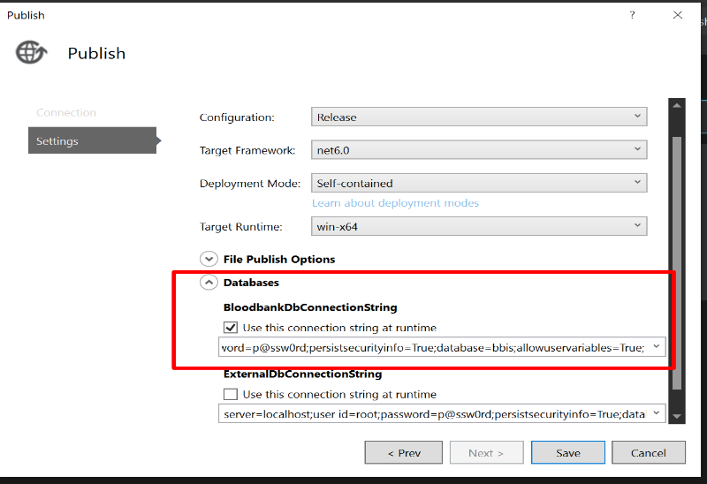

1. Now then click the Publish button and wait for the process to finish. 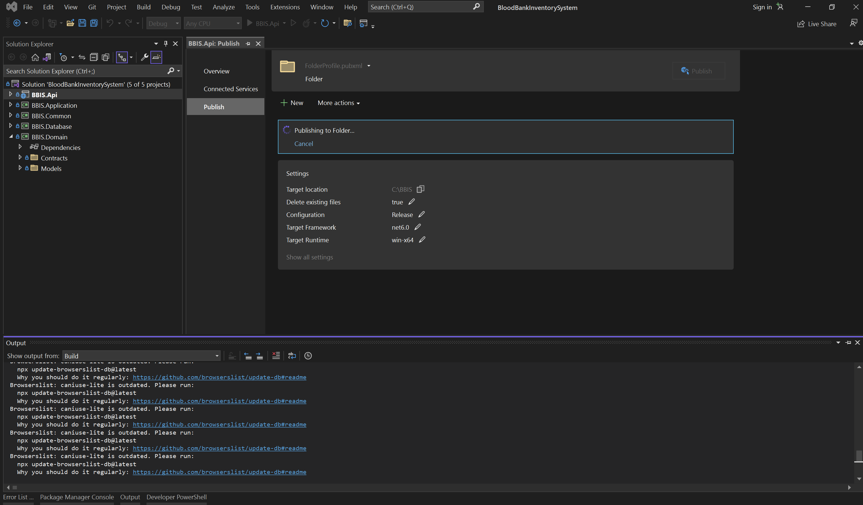
2. Once done, you would see a Publish succeeded message, you may navigate to the publish folder and use it to deploy in IIS.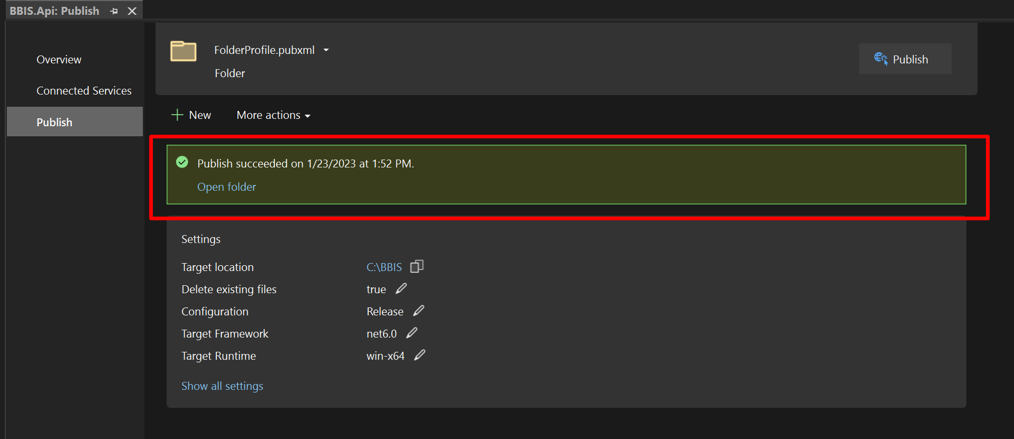

## Deploying to IIS

1. Open IIS, then click the Application Pools

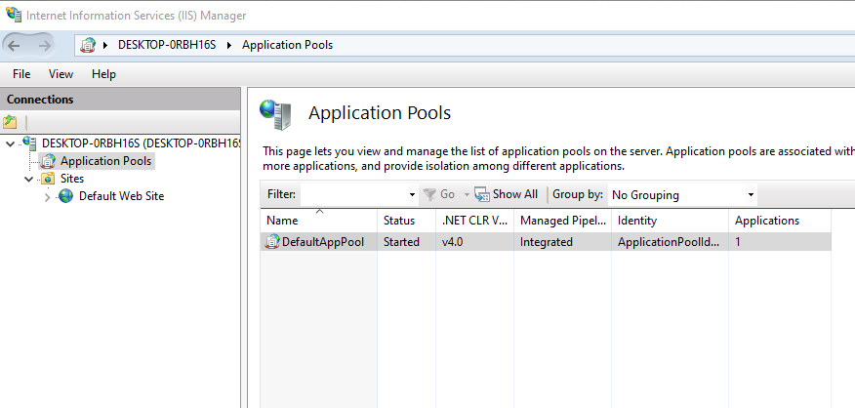

1. Add Application Pool by right clicking the Application Pools menu, and named your app pool and click Ok.

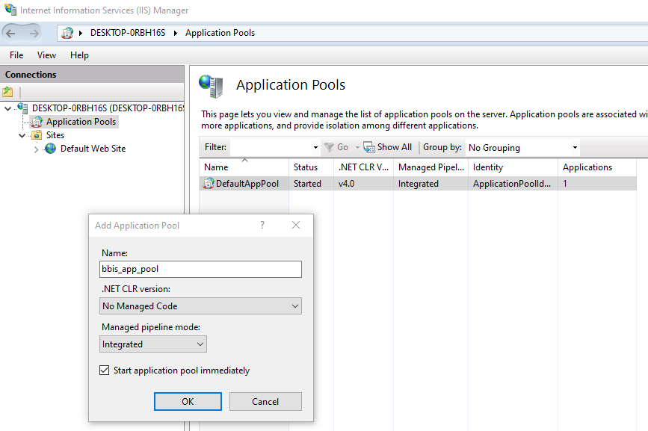

1. On the Sites menu, right click to Add Website,
   1. enter the Site name,
   2. then select the Application pool that was created earlier
   3. locate the published app on you drive
   4. enter the port number
   5. finally click Ok button.

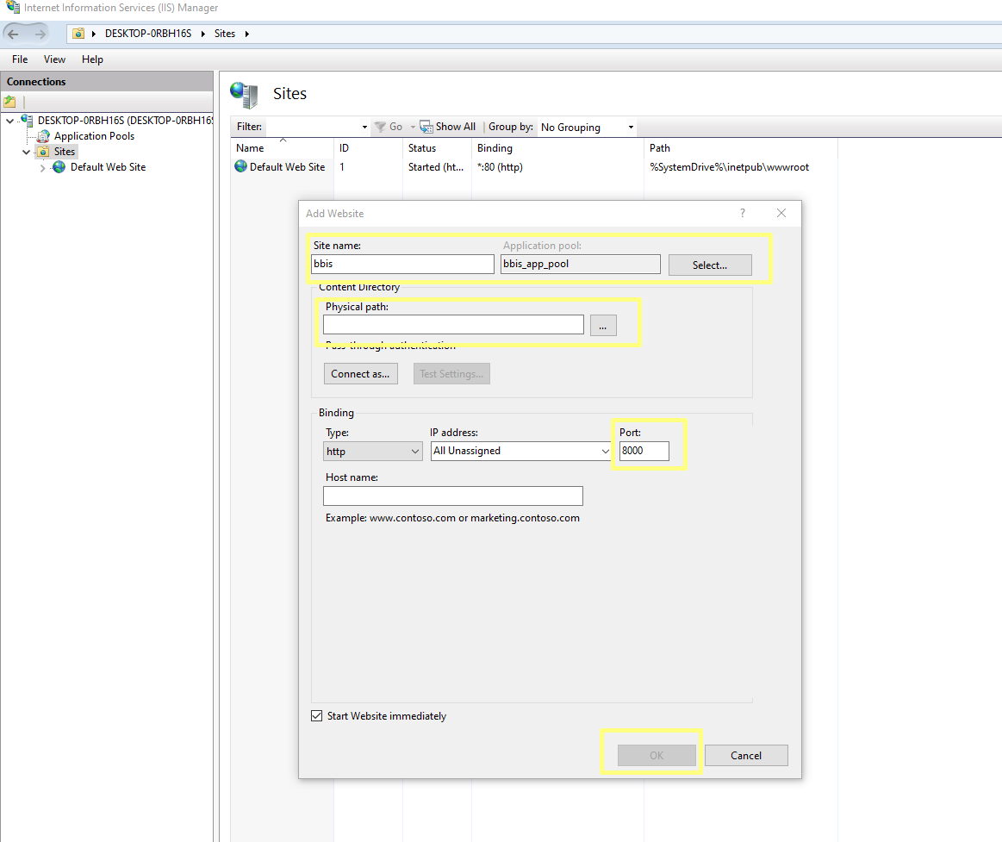

1. Open the browser and navigate to https://localhost:8000